Marwadi Education Foundation’s Group of Institutions

PROJECT

NGO APPLICATION



Under subject of

Software Engineering

(2160701)

(FOE - IT Branch)

|  |  |  |
| --- | --- | --- |
| Sr. | Name of student | Enrolment No. |
| 1 | Abhijeet Karmakar | 150570116011 |
| 2 | Vibhu Vijayan | 150570116035 |

Guided by:

Prof. Navjotsinh Jadeja

NGO APPLICATION

1.0 INTRODUCTION

1.1 PROJECT SUMMARY

1.2 PURPOSE

1.3 PROJECT SCOPE

2.0 PROJECT MANAGEMENT

2.1 PROJECT PLANNING AND SCHEDULING

2.2 RISK MANAGEMENT

2.3 ESTIMATION

3.0 SYSTEM REQUIREMENT STUDY

3.1 USER CHARACTERISTICS

3.2 CONSTRAINTS

4.0 SYSTEM ANALYSIS

4.1 STUDY OF CURRENT SYSTEM

4.2 PROBLEM AND WEAKNESSES OF CURRENT SYSTEM

4.3 REQUIREMENTS OF NEW SYSTEM

4.4 FEASIBILITY STUDY

4.5 REQUIREMENT VALIDATION

4.6 REQUIREMENT VALIDATION

4.7 EXTERNAL REFERENCES OF SYSTEM

4.8 EXISTING RESEARCH PAPER

**1.0 INTRODUCTION**

**1.1 PROJECT SUMMARY**

NGO – Application is a Web based application which joins the local people (needy people) of the world to the available NGOs around them. NGO- Mobile Application is designed with a mission that all non-profits, non-governmental organizations (NGO), churches, schools, missions, should have a mobile presence. You can have all your supporters, friends, members, partners, sponsors, missionaries interact with your non-profit organization via their mobile phones or PC / Desktop.

**1.2 PURPOSE**

The main purpose for which we are developing this application is to provide necessary information about NGOs and available government schemas to the local people or the needy people.

**1.3 PROJECT SCOPE**

Product scope defines what the product will look like, how will it work, its features, etc. Our application will have features like Mapping System, Donation System, Payroll System, Other Payment System, Online Blood donation etc.

**FEATURES :**

* Appearance
* Content
* Functionality
* Website Usability
* Search Engine Optimization

**2.0 PROJECT MANAGEMENT**

**2.1 PROJECT PLANNING AND SCHEDULING**

**SCHEDULING TIMELINE USING GANTT CHART:**

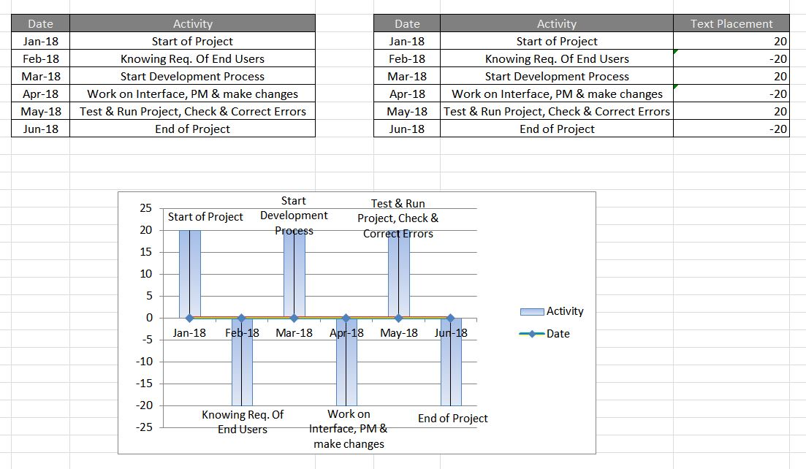

Git-Hub Link: [Gantt Chart.xlsx](https://github.com/vijayanvibhu/Software-Engineering/blob/master/Gantt%20Chart.xlsx)

**2.2 PROJECT PLANNING AND SCHEDULING**

**THE RISK MITIGATION, MONITORING AND MANAGEMENT:**

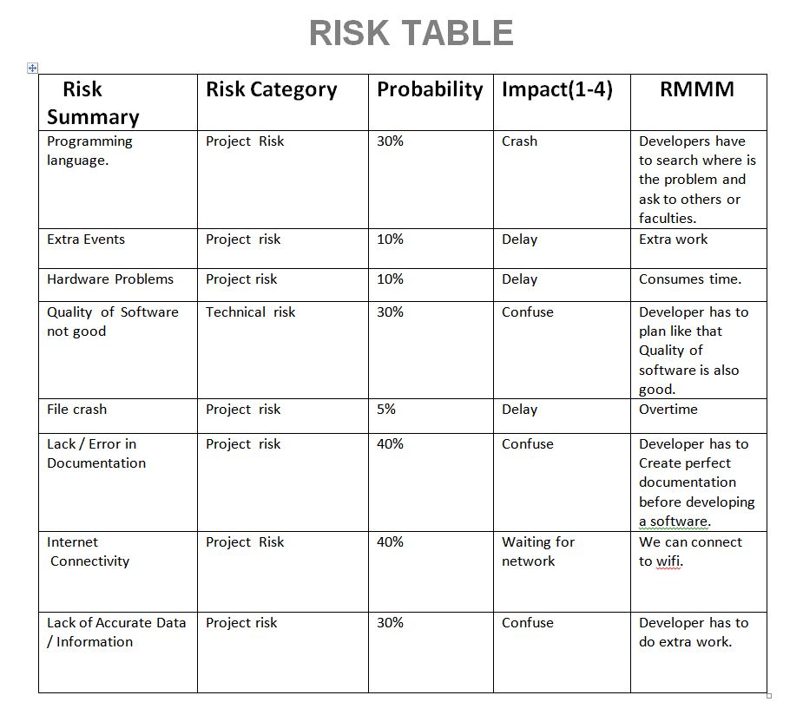

Git-Hub Link: [RMMM Doc.docx](https://github.com/vijayanvibhu/Software-Engineering/blob/master/RMMM%20Doc.docx)

**3.0 SYSTEM REQUIREMENT STUDY**

**3.1 USER CHARACTERISTICS**

**TARGETED AUDIENCE:**

The targeted audience of our mobile application is the one who wants to be an part of the application in one or the other way, either by helping to the less fortunate ones or by taking the help from any forums or

Organization.

**LIST OF AUDIENCES:**

* Corporate Professional Workers( Office going workers, Other Officials, Businessman, Government Official)
* Differently Abled Class( Orphanage, Handicapped Institutes, Homes for Blinds)
* Non-Professional Workers( Students, Household Wife, Aged Peoples, Unemployed peoples)
* Other Workers/Audience [ Farmers, Daily Wage Workers, Nursery(Plant Care Takers)]

**3.2 CONSTRAINTS**

**1) HARDWARE REQUIREMENTS OF THE SYSTEM :**

This phase of the software development process deals with a brief study of different hardware used in the computerized system. There is a list of hardware materials used during the making and also during the use of the proposed system. As the new system to be made into a computerized functional system, requirement of a computer is must. All the hardware needed here are generally the basic configuration of a typical office computer. A list of the hardware requirement used in the system given below:

* **Minimum Configuration :**

To run the application software of the system in the computer the minimum configuration required is as below:

* + 233 MHz Pentium processor or other compatible higher versions.
  + Intel Chipset Motherboard.
  + 32 MB SD – RAM.
  + 2 – 4 GB Hard – Disk.
  + Monitor[640 x 480 Display].
  + Keyboard.
  + Mouse.
    - **Recommended Configuration :**

The system can run on the above mentioned system, however for perfectness and clearness it is recommended to use a computer system having the below listed configuration. The configuration listed below can give best and optimum result at instance during the working of the system.

* + 1GHz Pentium 4 processor or other compatible.
  + Intel 81x Chipset Motherboard.
  + 128 MB SD – RAM.
  + 10 -20 GB Hard – Disk.
  + Color Monitor. [800 x 600 Display]
  + Keyboard.
  + Mouse.
  + 500 V. A UPS .[Used in case of power failure]

**Note:** The proposed system of NGO Application can work on both the above mentioned computer configuration. It is just for knowledge that the system can also work with the old technology as well as the new technology.

**2) SOFTWARE REQUIREMENTS OF THE SYSTEM :**

Along with the hardware, used in the system it requires software to make a system as well as to run a system with the computer hardware. Collection of different types of hardware into a specific type can from computer but it cannot execute process on its own. For efficient and proper working of any system software must be installed. There

Software’s may be in the form of operating system or application software.

To make the NGO Application, we are going to use certain softwares which are listed below.

**Software used in designing(code) of the system:**

* Windows 10 OS
* Android Studio
* Android OS

The software’s used in the proposed system are the latest versions of them and can give up-to-date and perfect result of every process in the system. Their software comprises operating system and application software used in the system.

**4.0 SYSTEM ANALYSIS**

**4.1 STUDY OF CURRENT SYSTEM**

* Impact on End Users
* Native NGO apps v/s App that connect user-to-user
* Marketplace
* Consumer preferences in the application
* Role of Network providers
* Security and Privacy issues

**4.2 PROBLEM AND WEAKNESSES OF CURRENT SYSTEM**

**PROBLEMS:**

* Knowledge of any such application.
* Unavailability of prerequisite gadget/instrument.
* Lack of knowledge to operate the application.
* Geographical barriers.
* Acceptability of the system by the end-users.
* Cellular Network issues.
* Sometimes may happen parties using the application cannot connect or communicate due to technical problems.

**WEAKNESS:**

* Application is restricted to a specific location.
* Application is built for certain specific tasks.
* Language barrier.
* Lesser communication with the end-users.
* If requirement for accessing the application is missing, the user cannot or will get denied from using the system.

**4.3 REQUIREMENTS OF NEW SYSTEM**

**1) HARDWARE REQUIREMENTS OF THE SYSTEM :**

This phase of the software development process deals with a brief study of different hardware used in the computerized system. There is a list of hardware materials used during the making and also during the use of the proposed system. As the new system to be made into a computerized functional system, requirement of a computer is must. All the hardware needed here are generally the basic configuration of a typical office computer. A list of the hardware requirement used in the system given below:

* **Minimum Configuration :**

To run the application software of the system in the computer the minimum configuration required is as below:

* + 233 MHz Pentium processor or other compatible higher versions.
  + Intel Chipset Motherboard.
  + 32 MB SD – RAM.
  + 2 – 4 GB Hard – Disk.
  + Monitor[640 x 480 Display].
  + Keyboard.
  + Mouse.
    - **Recommended Configuration :**

The system can run on the above mentioned system, however for perfectness and clearness it is recommended to use a computer system having the below listed configuration. The configuration listed below can give best and optimum result at instance during the working of the system.

* + 1GHz Pentium 4 processor or other compatible.
  + Intel 81x Chipset Motherboard.
  + 128 MB SD – RAM.
  + 10 -20 GB Hard – Disk.
  + Color Monitor. [800 x 600 Display]
  + Keyboard.
  + Mouse.
  + 500 V. A UPS .[Used in case of power failure]

**Note:** The proposed system of NGO Application can work on both the above mentioned computer configuration. It is just for knowledge that the system can also work with the old technology as well as the new technology.

**2) SOFTWARE REQUIREMENTS OF THE SYSTEM :**

Along with the hardware, used in the system it requires software to make a system as well as to run a system with the computer hardware. Collection of different types of hardware into a specific type can from computer but it cannot execute process on its own. For efficient and proper working of any system software must be installed. There

Software’s may be in the form of operating system or application software.

To make the NGO Application, we are going to use certain software’s which are listed below.

**Software used in designing(code) of the system:**

* Windows 10 OS
* Mozilla Firefox
* Xampp Control Panel
* Notepad ++
* Sublime Text

The software’s used in the proposed system are the latest versions of them and can give up-to-date and perfect result of every process in the system. Their software comprises operating system and application software used in the system.

**4.4 FEASIBILITY STUDY**

A feasibility study is undertaken to determine the possibility or probability of either improving the existing system or developing a completely new system.

It helps to obtain an overview of the problem and to get rough assessment of whether feasible solution exists.

This is essential to avoid committing large resources to a project and then repent on it later.

There are three aspects in feasibility study portion of the preliminary investigation.

* 1. Technical feasibility.
  2. Economic feasibility and
  3. Operational feasibility of the project.

**1) Technical feasibility**

* + - * Technical feasibility determines whether the work for the project be done with the present equipment, current procedures, existing software’s technology and available personnel.

## **Windows**

To use on Windows, you'll need:

* Windows 7, Windows 8, Windows 8.1, Windows 10 or later
* An Intel Pentium 4 processor or later that's SSE2 capable

**Note:** Servers require Windows Server 2008 R2 or Windows Server 2012.

## **Mac**

To use on Mac, you'll need:

* OS X Mavericks 10.9 or later

## **Linux**

To use on Linux, you'll need:

* 64-bit Ubuntu 14.04+, Debian 8+, openSUSE 13.3+, or Fedora Linux 24+
* An Intel Pentium 4 processor or later that's SSE2 capable

**2)** **Economic feasibility:**

Economic feasibility looks at the financial aspects of the project Economic feasibility concerns with the returns from investments in a project. It determines whether it is worthwhile to invest the money in the proposed system. It is not worth while spending a lot of money on a project for no returns.

To carry out an economic feasibility for a system, it is necessary to place actual money value against any purchases or activities needed to implement the project.

**3) Operational feasibility:**

Operational feasibility covers two aspects. One is the technical performance aspect and other is the acceptance within the organization. Operational feasibility determines how the proposed system will fit in the current operations and what, if any job restructuring and retraining may be needed to implement the system.

In the system operational feasibility checks, whether the user who is going to use the system is able to work with the software’s with which the system is coded and also the mind of the user going to use the system. If the user does not understand or is able to the work on the system further development is of waste.

**4.5 REQUIREMENT ELICITATION**

Requirements Elicitation is the practice of collecting the requirements of a system from users, customers and other stakeholders. The practice is also sometimes referred to as requirement gathering.

* Identify the real problem, opportunity or challenge?

Problem what we are facing is that everybody has a intent to do something but is lacking in either ways. If they want to donate something such as, Clothes, Old books etc. they are not able to find the platform and somewhere where someone is already having platform either they lack the donating resources or due to geographical location.

**4.6 REQUIREMENT VALIDATION**

Requirements validation is an iterative process which takes place throughout the lifecycle of the project. During elicitation, analysis and specification you should constantly be questioning and clarifying the data given to you in order to check its validity.

All the information stored in our app is taken from the authenticated government sites, which you can verify.

**4.7 EXTERNAL REFERENCES OF SYSTEM**

**CURRENT APPLICATION OR SYSTEM:**

* <http://www.gujarat.ngosindia.com/> - This website contains information about available NGO’s across Gujarat.
* <http://www.giveindia.org/> - This website contains features like Donation, Fundraising and Payroll Giving System.
* [Udaan : NGO App](https://play.google.com/store/apps/details?id=com.udaan&hl=en) - Udaan is an NGO working for society and betterment of humanity. This application has all our details. Our work profile and regular event updates with photos.
* [Sankalp NGO - SANKALP](SANKALP%20is%20an%20initiative%20taken%20in%20the%20memory%20of%20Late%20Sh.%20Sunil%20Nagrath%20(1959-2014)%20whose%20ideals%20and%20kindness%20inspire%20the%20foundation%20of%20the%20NGO.) - is an initiative taken in the memory of Late Sh. Sunil Nagrath (1959-2014) whose ideals and kindness inspire the foundation of the NGO. SANKALP was founded on 1st December 2014 by Smt. Archna, a Private Teacher. Being a tough journey at the beginning, SANKALP found its supporters from various fields of society as the journey proceeded.
* [Do-Nation NGO](https://play.google.com/store/apps/details?id=com.mrs.donation) - Do-Nation is a NGO volunteering organization working together with local communities and volunteers committed towards empowering rural India.

**4.8 EXISTING RESEARCH PAPER**

* “Donation facilitator social network” by Idan Rubin, Ori Kremer and Raju Ayyagari - [Google Patent Link](https://www.google.es/patents/US20110054986)
* “Methods of online fund raising over a network” by Dominic Lacey, Will Hardy, Richard Marr, Jason Horton - [Google Patent Link](https://www.google.com/patents/US20060167765)
* “System for web-based payroll and benefits administration” by David Kahn, Barinder Singh Saini, Svetlana E. Kreimer - [Google Patent Link](https://patents.google.com/patent/US6401079B1)
* “NGOs and organisational change” by Ebrahim.
* “Understanding Development as a Living Process” by Kalpan*.*